## **LAB Assignment No. 4**

## **Question 1: Random Forest on Iris Dataset**

### **Python Code**

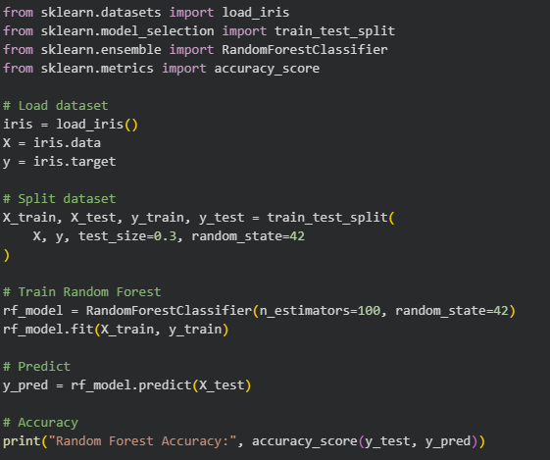

### **Output**

## **Question 2: SVM on Breast Cancer Dataset**

### **Python Code**

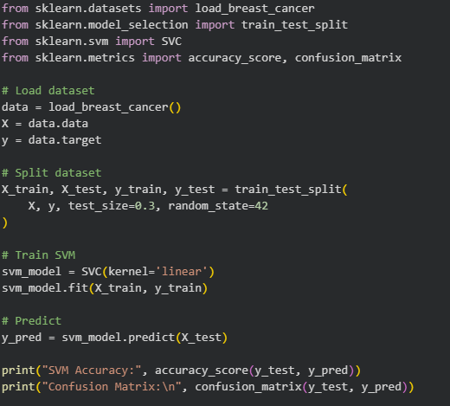

### **Output**

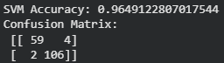

## **Question 3: Random Forest on Custom CSV Dataset**

**Python Code**

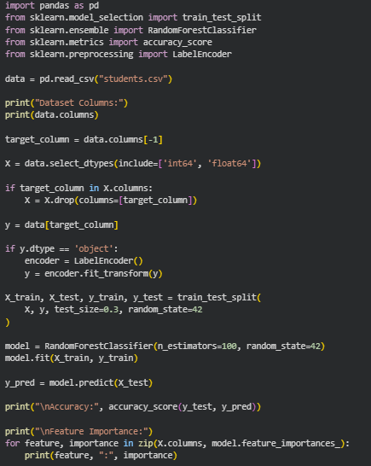

### **Output**

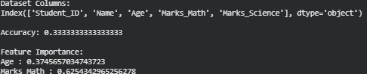

## 

## 

## **Question 4: SVM on Digits Dataset**

**Python Code**

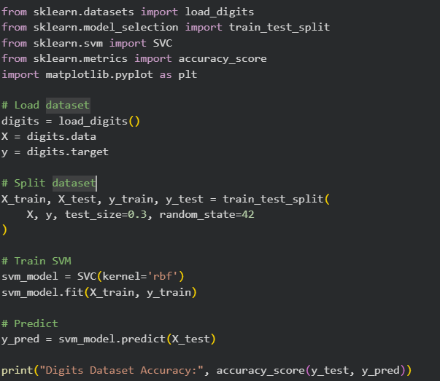

### **Output**



## **Question 5: Random Forest vs SVM (Wine Dataset)**

### **Python Code**

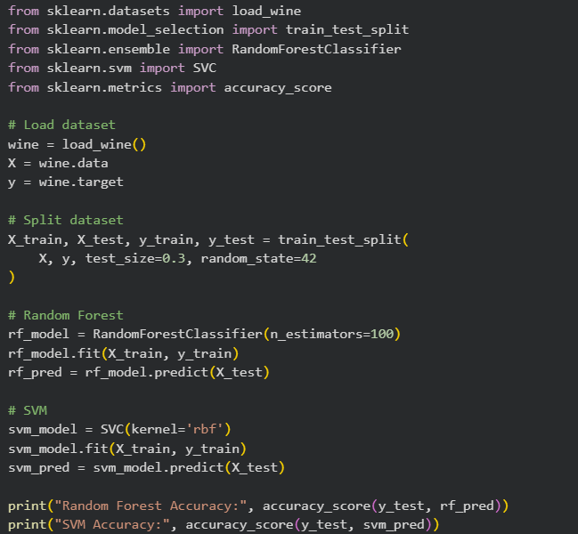

### 

### **Output**

